Video 1 : Introduction and various phases of compiler

Lexical Analysis -> Synatx Analysis -> Symantic Analysis -> Intermediate code generation -> Code Optimization -> Target Code Gen

Video 2 : Introduction to lexical analyzer and Grammars

Ambiguity problem is undecidable.

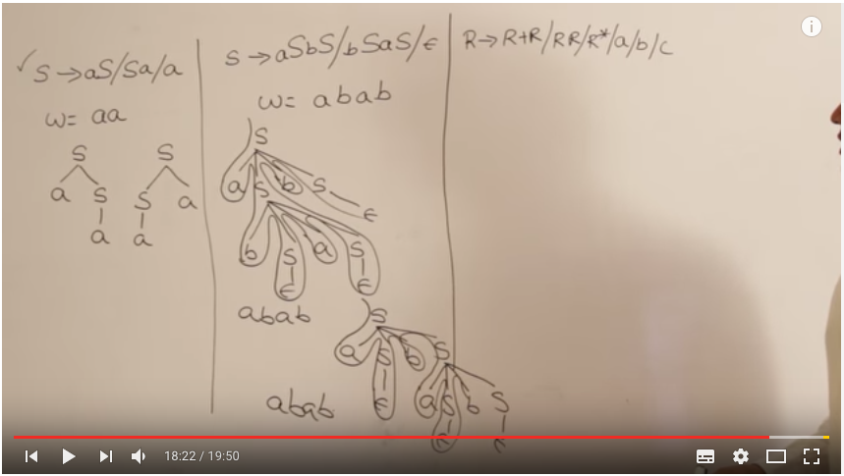

Video 3 : Ambiguous grammars and making them unambiguous

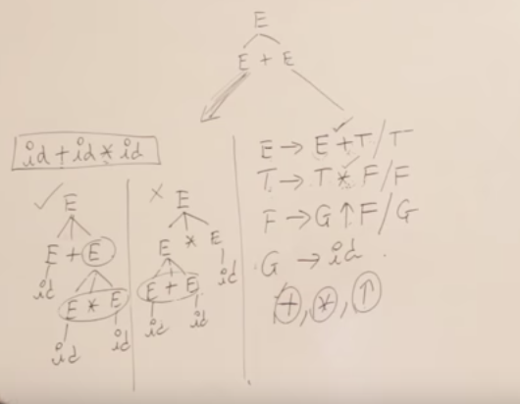

operator with highest precedence is at bottom,e.g. +,\*,Power.

+,\* are left associative, power is right associative(F->G pow F | G)

Video 4 : Elimination of left recursion and left factoring the grammars

Most parsers ( esp. top down parsers) don’t work properly with left recursive grammars

Eliminating Left recursion

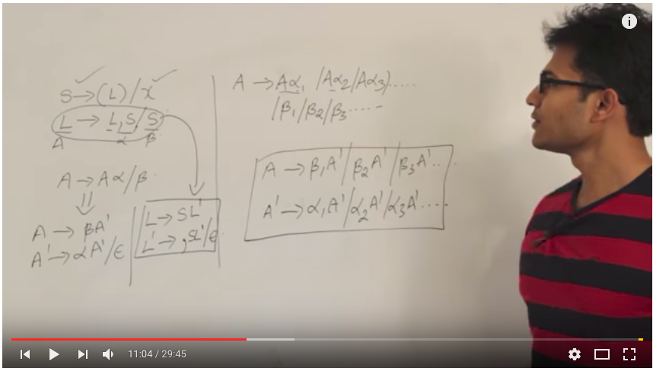

Eliminating Left factoring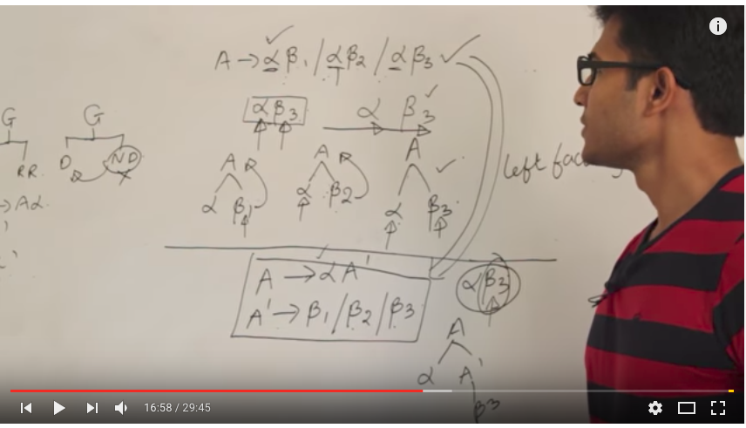

Video 5 : Introduction to parsers and LL(1) parsing

TDP(Full Backtracking(BruteForce) & Without Backtracking ) & BUP

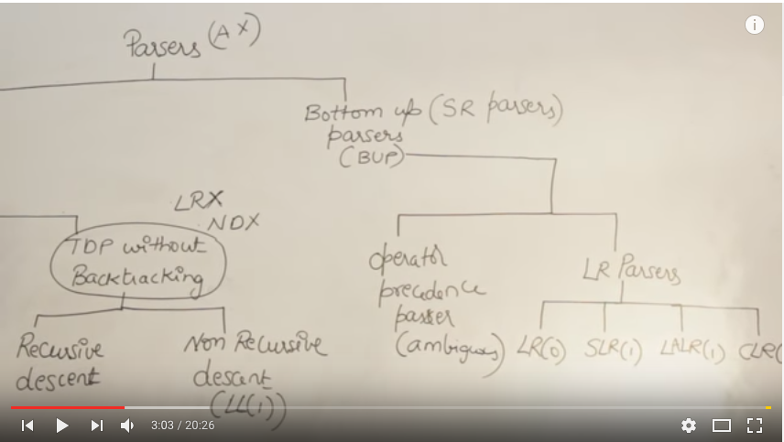

Video 6 : Examples on how to find first and follow in LL(1)

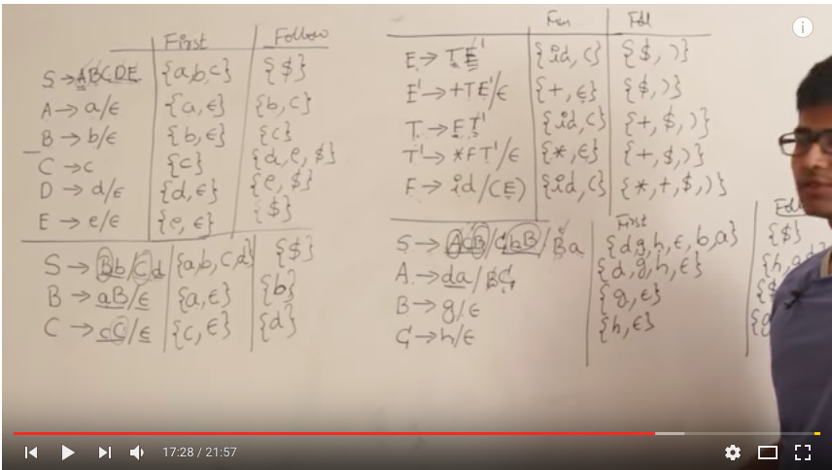

Video 7 : Construction of LL(1) parsing table

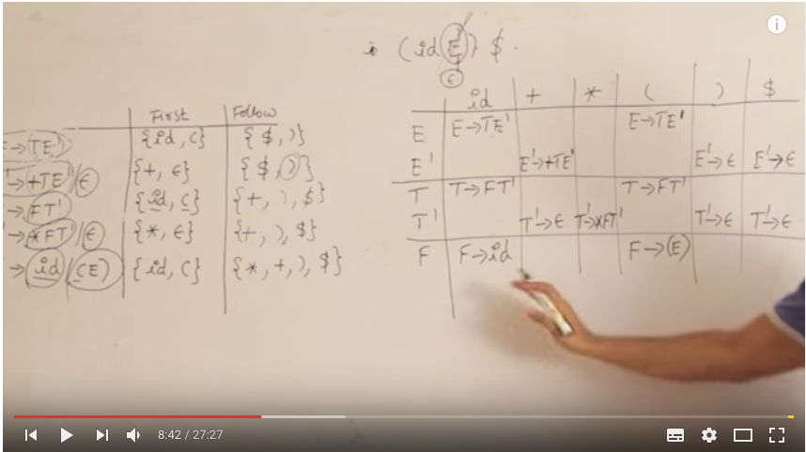

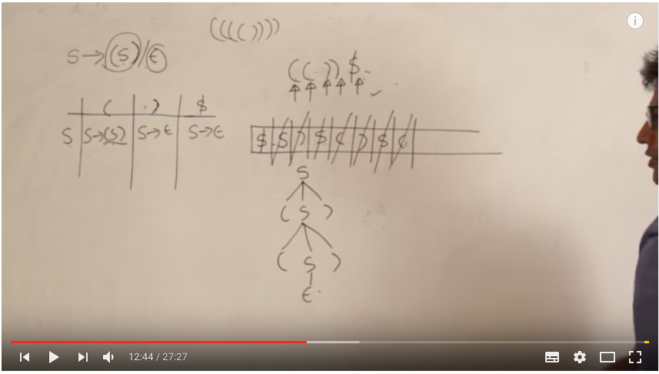

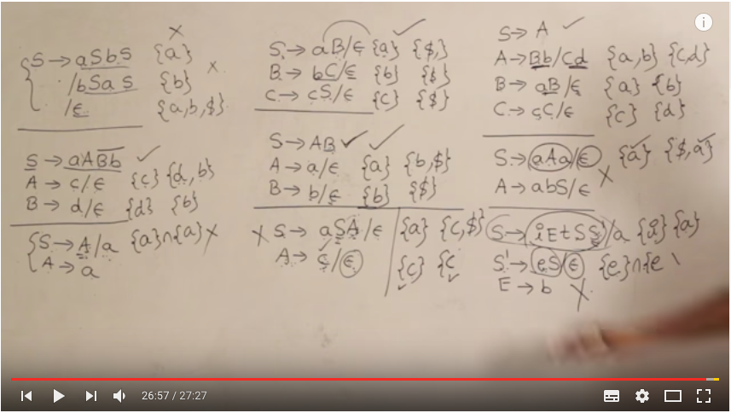

Video 8 : Recursive descent parser

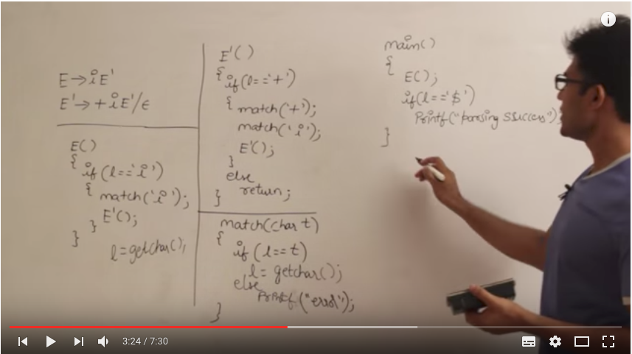

Video 9 : Operator grammar and operator precedence parser

No two variables can be together like E->EAB, A->+,\*

it should be E->E+E/E\*E

No epsilons should be there.

Push to stack if, top of stack has lower precedence than element

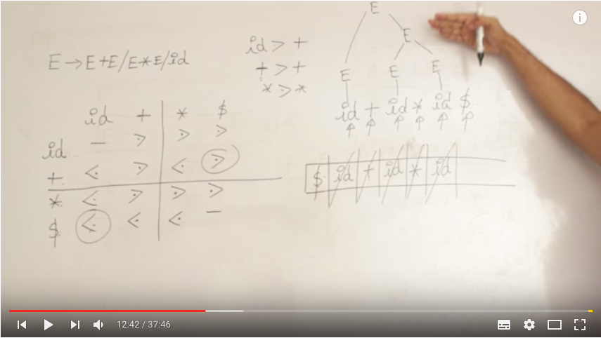

disadv: size of table is square of of terminals

Using function table, size becomes 2n. But, extra measures to determine empty cells/equal priority

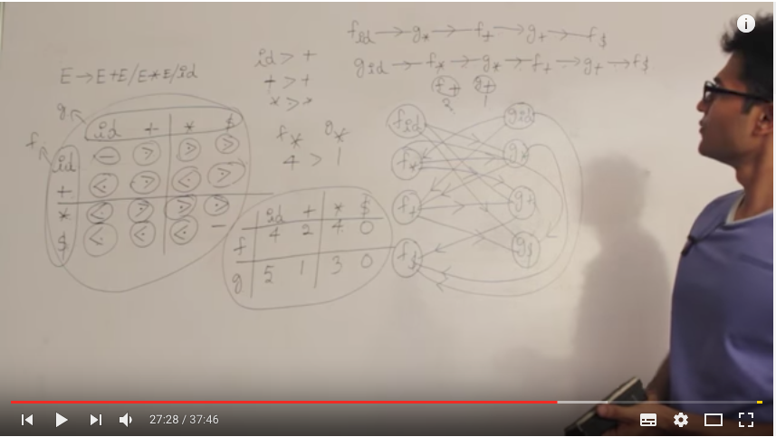

Video 10 : LR Parsing, LR(0) items and LR(0) parsing table

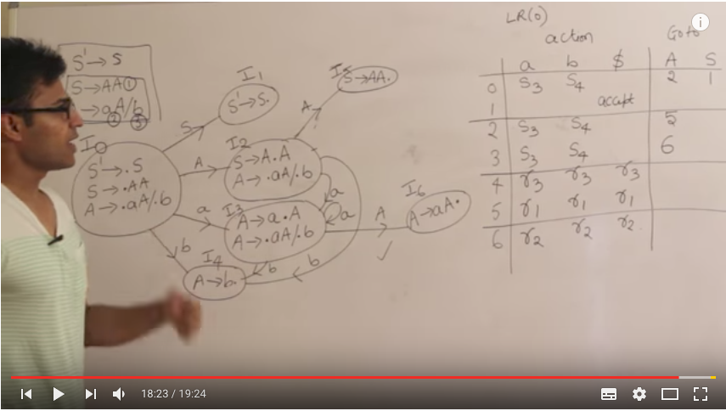

Video 11 : LR(0) parsing example and SLR(1) table

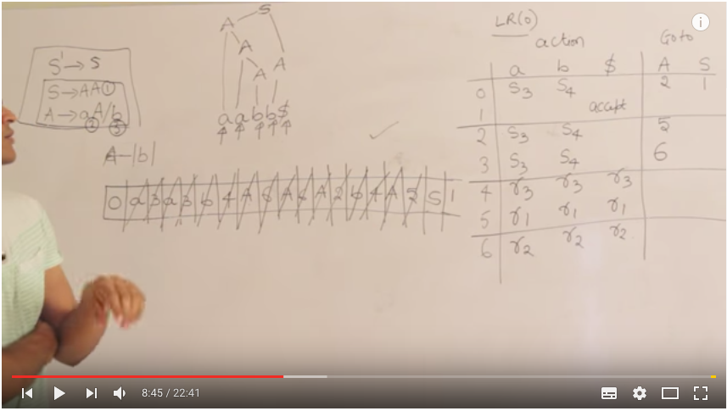

In SLR(1) just put reduce moves only in follow of LHS. Hence detects error faster.

SR/LR Conflicts

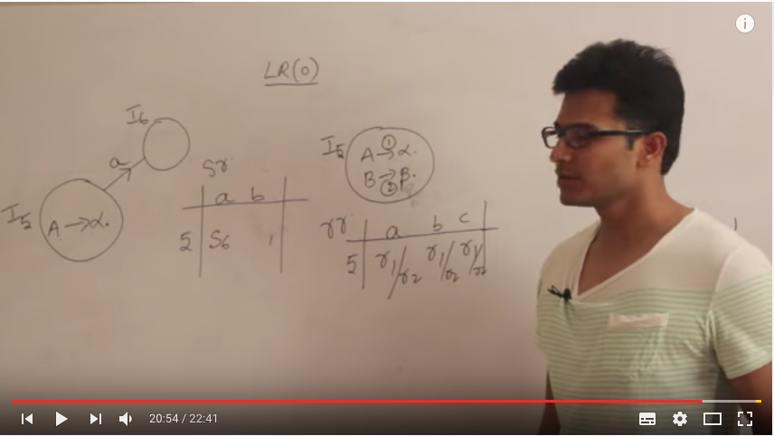

Video 12 : Examples of LR(0) and SLR(1)

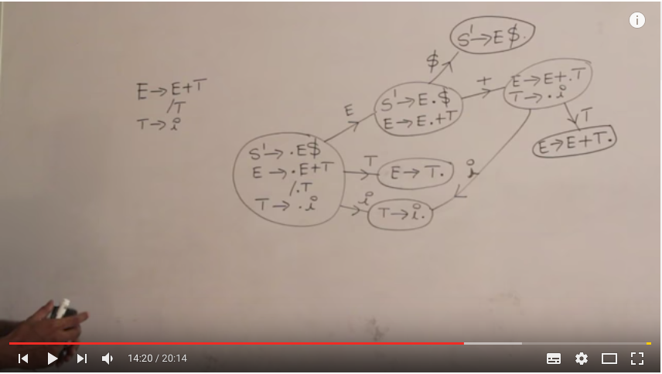

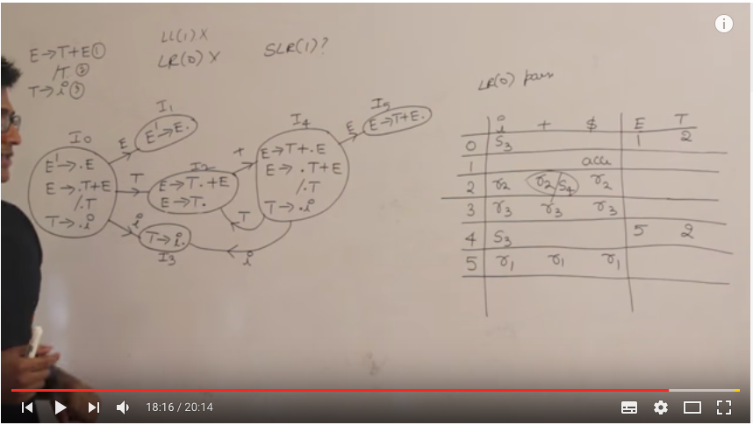

above grammar is SLR(1) grammar.

Video 13 : Examples of LR(0) and SLR(1) Continued

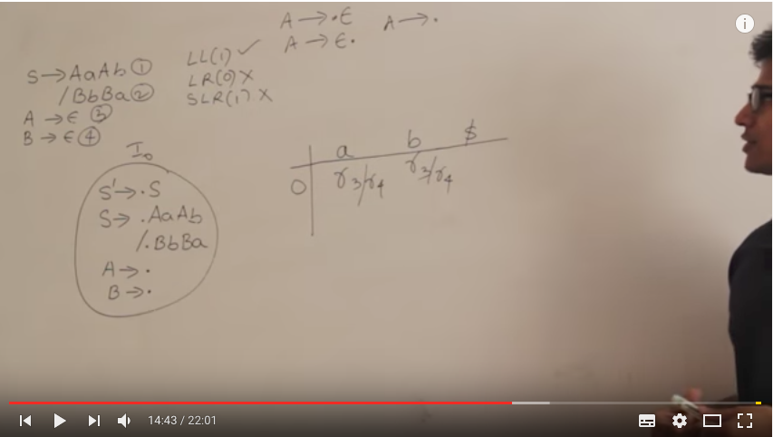

Video 14 : CLR(1) and LALR(1) Parsers

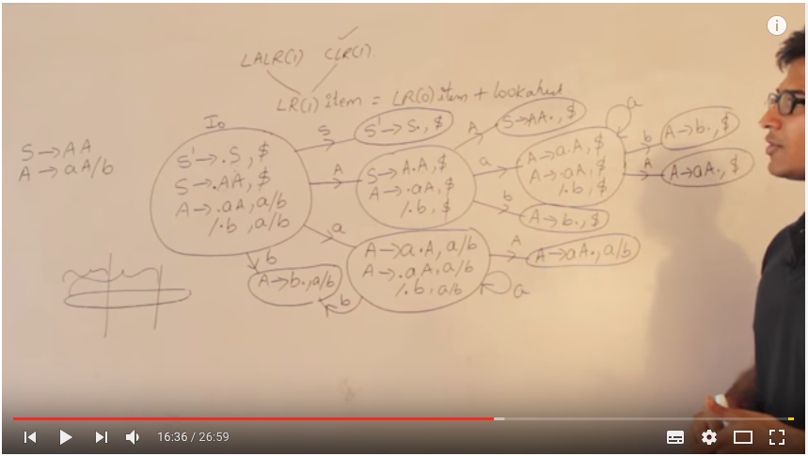

Video 15 : Conflicts and examples of CLR(1) and LALR(1)

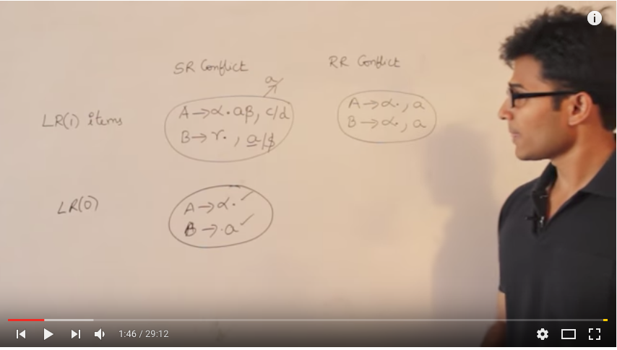

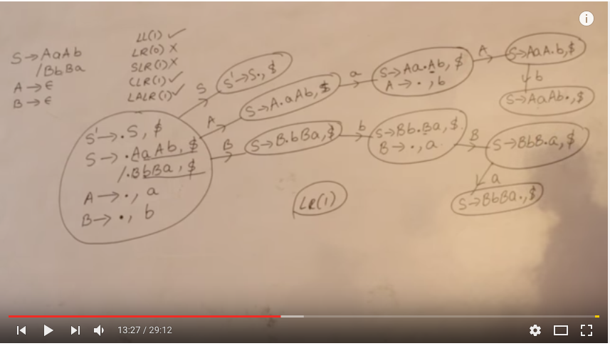

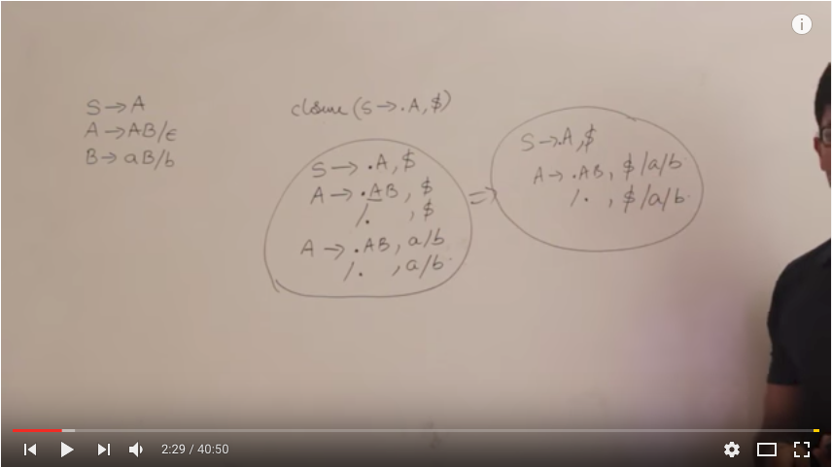

Video 16 : Example of CLR(1) and LALR(1) and comparision of all parsers

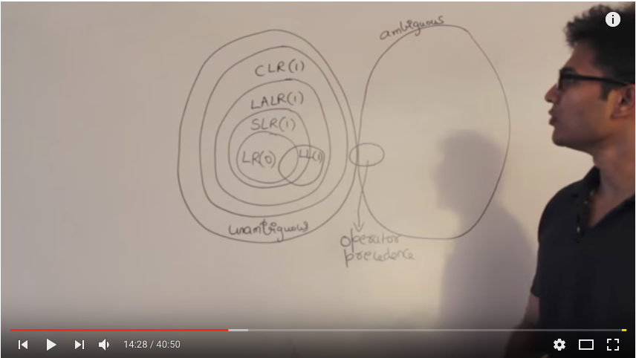

Video 17 : Syntax Directed Transaltion

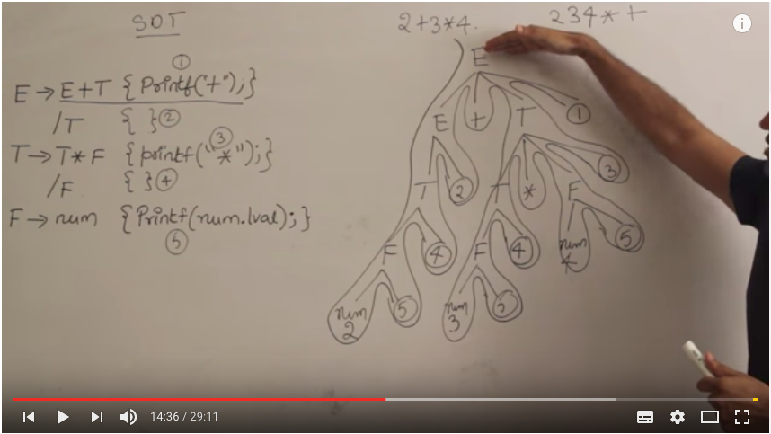

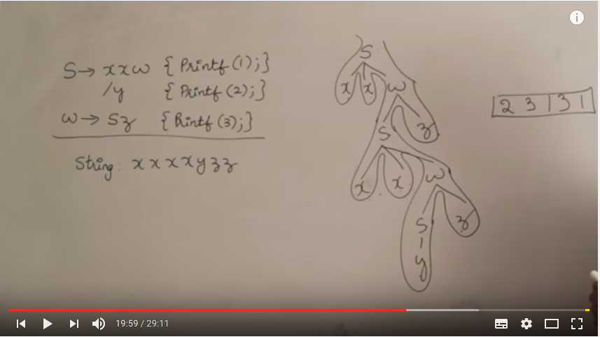

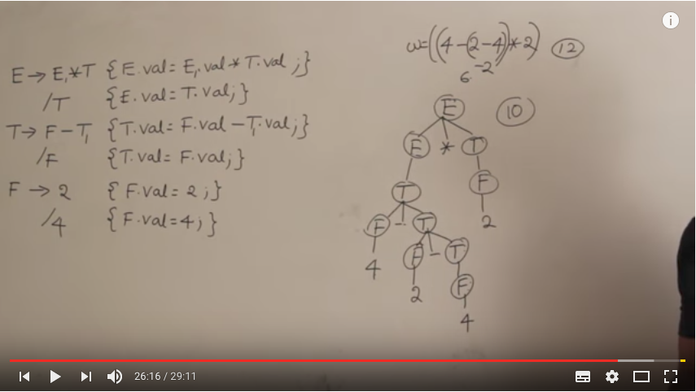

Video 18: Examples of SDT

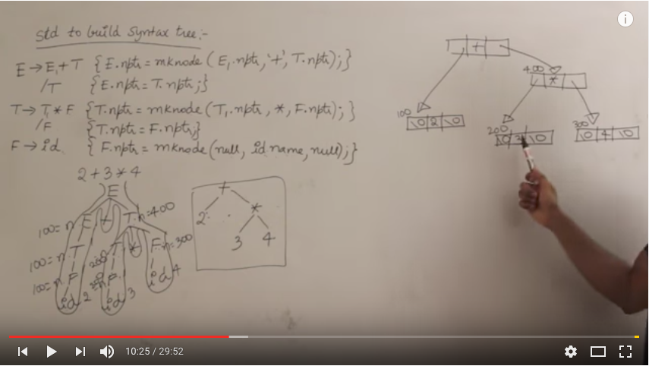

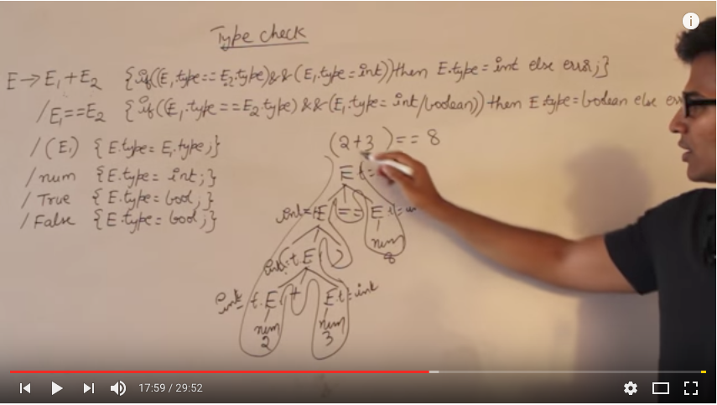

Video 19 : S attributed and L attributed

